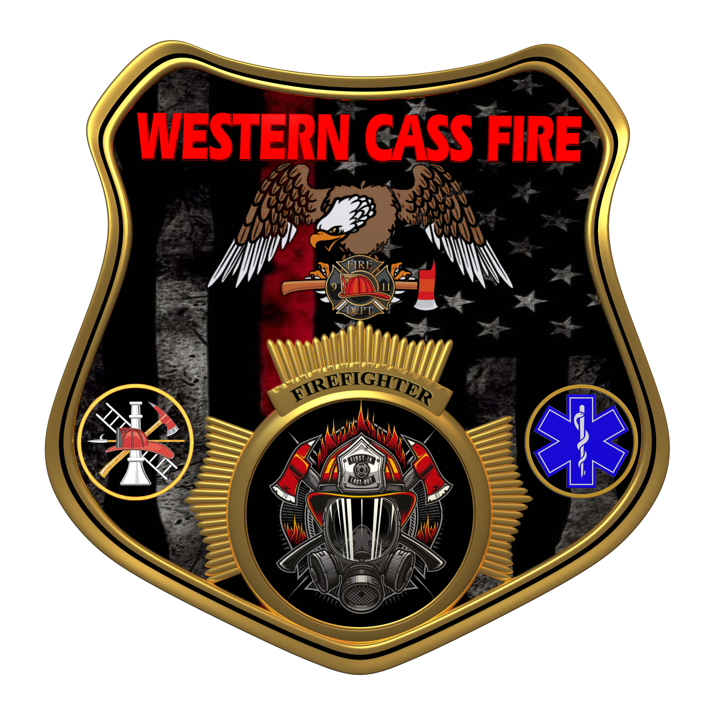 | Tentative Agenda  Western Cass Fire Protection District  Special Session Meeting  Wednesday, February 08, 2023, at 7:00 pm  Fire Headquarters  5 S. Rogers Road, Cleveland, MO 64734  In Person Only  Discussion Protocols and Organization Rules for Meetings:  Questions from the public must be in writing with the following information: Name, Phone #, Physical Address, Email Address.  Board Members will be limited to 3 minutes for discussion of agenda items, twice per item, and discussion of items will last no more than 10 minutes per item.
- Call to Order by the Secretary
- Pledge of Allegiance
- Roll Call (Quorum)
a) President and Chair John Webb (2022- 2027)
b) Vice Chair Marty Hardman (2022- 2023)
c) Director Sue Hosterman (2019-2025)
d) Director Kerri VanMeveren (2020-2026)
e) Director Darvin Schildknecht (2021-2027)
- Adopt and Approve Wednesday, February 08, 2023 Tentative Agenda
5) New Business
a) Insurance Agents
b) Town Hall Meeting
6) Unfinished Business
a) Smart Pro
7) Closed Session: Insurance Bids
Sealed bids and related documents, until the bids are opened; and sealed proposals and related documents or any documents related to a negotiated contract until a contract is executed, or all proposals are rejected; RSMo 610.021(12)
8) Adjourn

