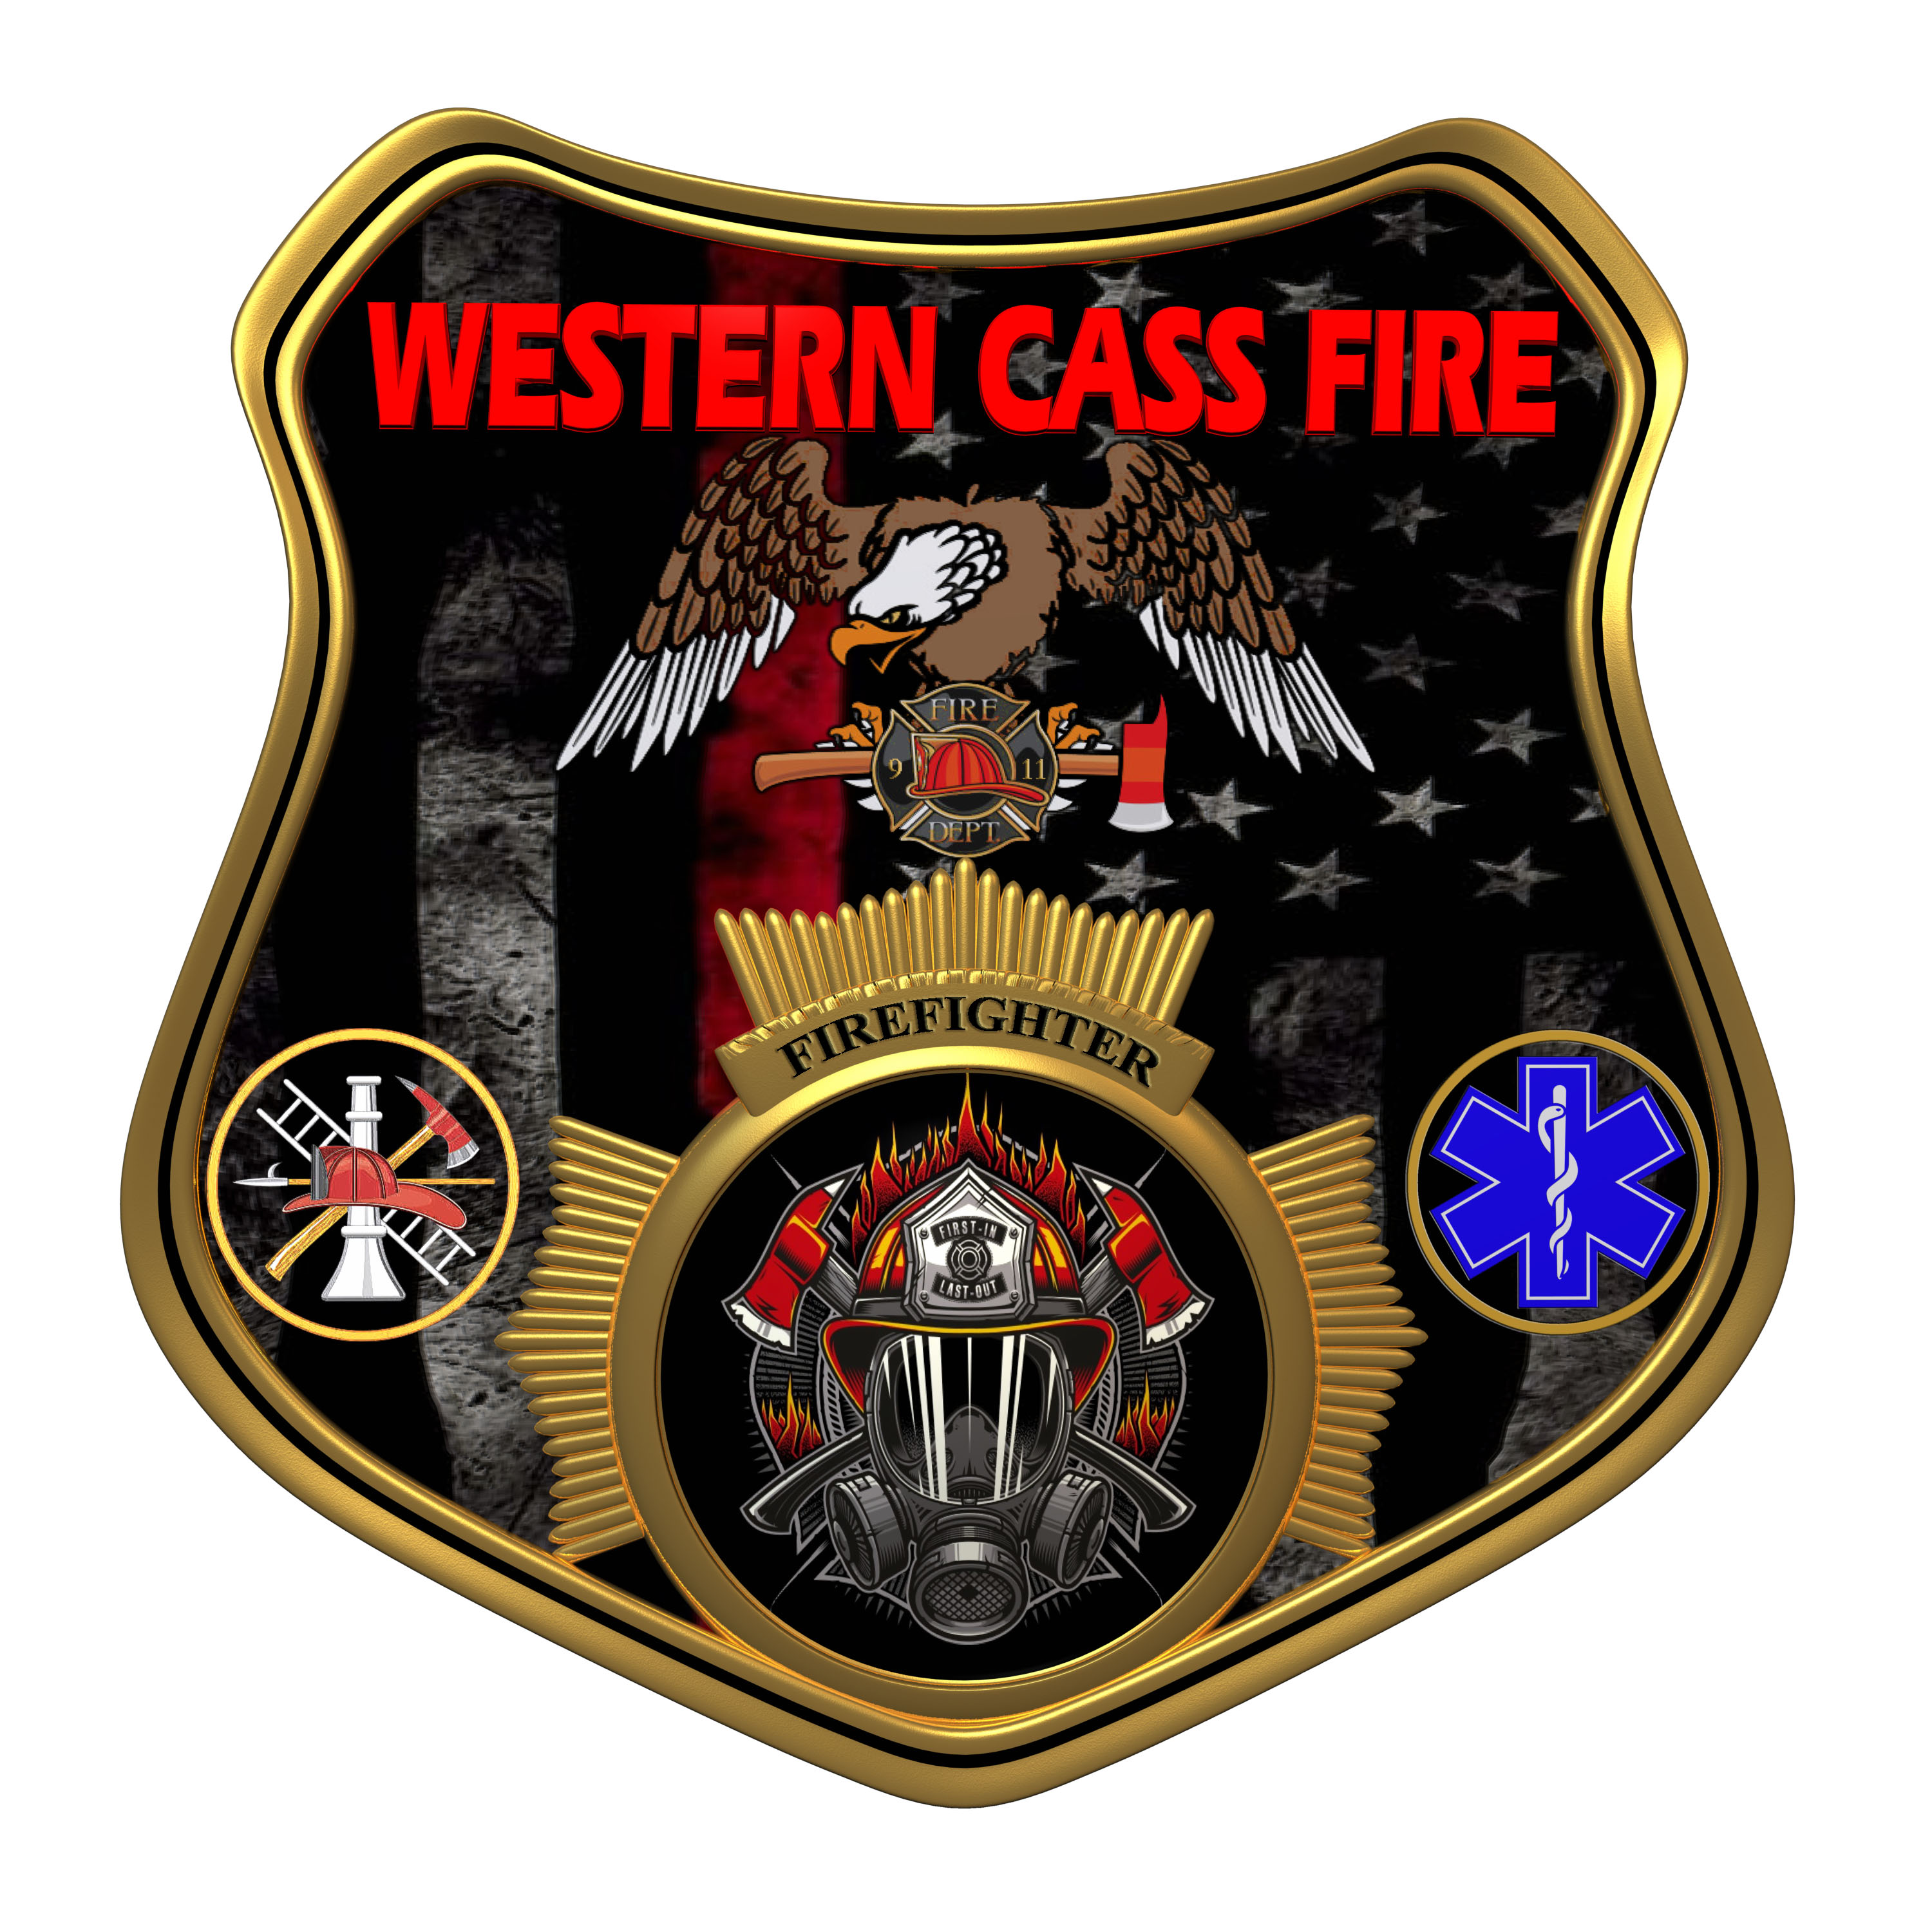 | Minutes  Western Cass Fire Protection District  Special Session Meeting  Wednesday, June 07 2023, at 7:00 pm  Fire Headquarters  5 S. Rogers Road, Cleveland, MO 64734  In Person Only
- Call to Order by the Secretary - 7:00 P.M.
- Pledge of Allegiance
3) Roll Call (Quorum)
a) President Sue Hosterman (2019-2025) Present
b) Vice Chair John Webb (2022- 2027) Absent
c) Director Tom Reintjes (2023- 2029) Present
d) Director Kerri VanMeveren (2020-2026) Present
e) Director Darvin Schildknecht (2021-2027) Present
4) Approve the minutes from May 17, 2023 Regular Session meeting - No Action Taken
5) Directors Reports - No Reports
6) New Business
a) Worker Compensation Insurance Acceptance and Payment
President Hosterman made a motion to accept the renewal from Travelers Insurance in the amount of $7,634.00 and allow the treasurer to pay the amount, and it passed.
President and Chair Sue Hosterman - Aye
Vice Chair John Webb - Absent
Director Tom Reintjes - Aye
Director Kerri VanMeveren - Aye
Director Darvin Schildknecht - Aye
President Hosterman made a motion to adjourn and it passed.
President and Chair Sue Hosterman - Aye
Vice Chair John Webb - Absent
Director Tom Reintjes - Aye
Director Kerri VanMeveren - Aye
Director Darvin Schildknecht - Aye

7) Adjourn : 7:18 P.M.

President Sue Hosterman _________________________________________________

Secretary Chris Johnson __________________________________________________

