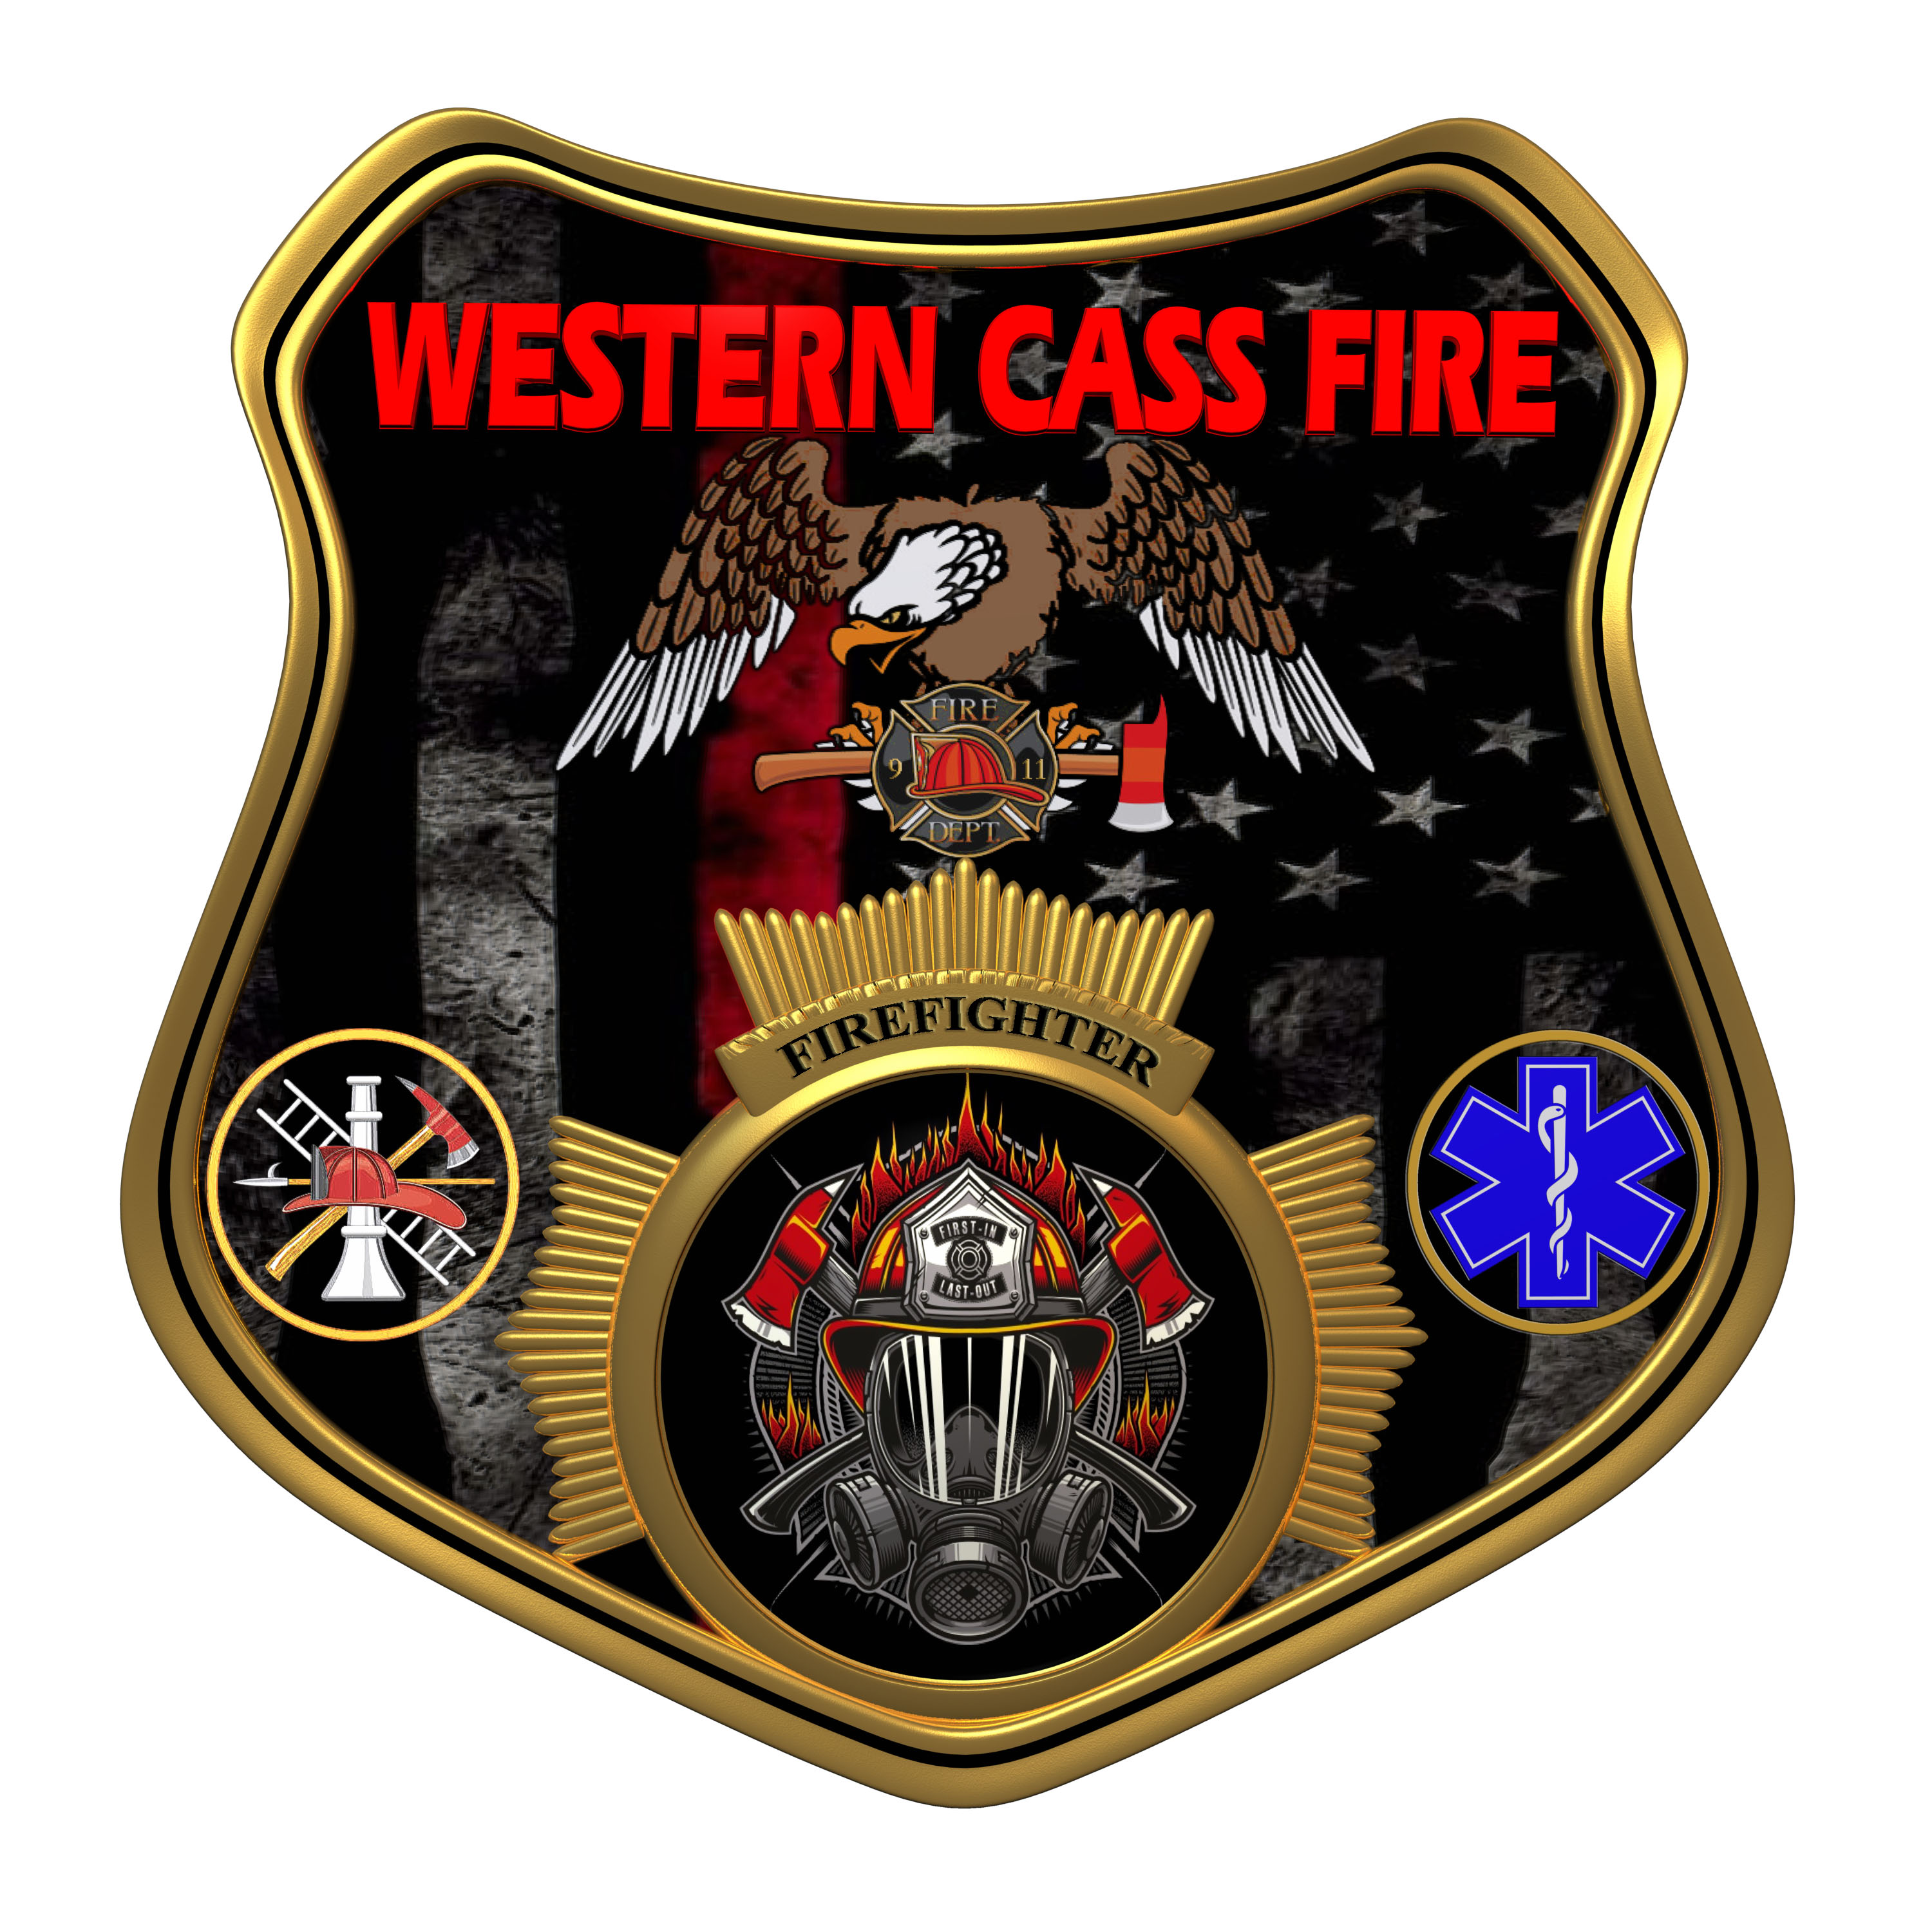 | Minutes  Western Cass Fire Protection District  Special Session Meeting  Wednesday, March 06, 2024, at 7:00 pm
- Call to Order by the Secretary – 7:10 P.M.
- Pledge of Allegiance
3) Roll Call (Quorum)
a) President Sue Hosterman (2019-2025) Present
b) Vice Chair John Webb (2022- 2027) Present (Arrived Late)
c) Director Tom Reintjes (2023- 2029) Present
d) Director Theresa Hawkins (2020-2025) Present
e) Director / Treasurer Mike Bigg (2021-2027) Present (Arrived Late)
4) a) President Hosterman made a motion to amend the agenda by adding Tax Levy and Open House to New business Section A, and it passed.
President Sue Hosterman - Aye
Vice Chair John Webb - Absent
Director Tom Reintjes - Aye
Director Theresa Hawkins - Aye
Director Mike Bigg - Absent

b) President Hosterman made a motion to approve the March 06, 2024 Special Session Meeting Tentative Agenda and Additions and it passed.
President Sue Hosterman - Aye
Vice Chair John Webb - Absent
Director Tom Reintjes - Aye
Director Theresa Hawkins - Aye
Director Mike Bigg - Absent

5) Public Comments
6) Treasurer Report
a) The new CPA has been compiling the year end 2023 statements.
b) The CPA will provide a quote for an audit.
c) The Missouri Auditor has provided the district with the history of the general revenue levy since our inception in 1983.
d) The last time the district levy was increased was 1987.
e) The new billing process is operating and the president and treasurer have real time access to the bills.
f) The goal is to generate monthly reports that are clean and accurate.
7) New Business
a) Open House / Tax Levy
1) The open house will be on March 23, 2024 at Station 1 from 2-4 P.M.
2) Mailers about the levy proposal are being sent to residents of the district.
3) Director Reintjes made a motion to approve up to $1000.000 for printing yard signs and banners for the stations to promote the levy increase, and it passed.
President Sue Hosterman - Aye
Vice Chair John Webb - Aye
Director Tom Reintjes - Aye
Director Theresa Hawkins - Aye
Director Mike Bigg - Aye
b) Chief Credit Limit
Director Bigg made a motion to increase the credit limit on Chief Porters district credit card to $6000.000, and it passed.
President Sue Hosterman - Aye
Vice Chair John Webb - Aye
Director Tom Reintjes - Aye
Director Theresa Hawkins - Aye
Director Mike Bigg - Aye
c) President Hosterman made a motion to go into closed session to discuss personnel issues and to include the secretary and Chief Porter, and it passed.
President Sue Hosterman - Aye
Vice Chair John Webb - Aye
Director Tom Reintjes - Aye
Director Theresa Hawkins - Aye
Director Mike Bigg - Aye

8) Unfinished Business
9) Closed Session: Personnel
Personnel matters are confidential until such time as they may be made public by the Board of Directors, and the nondisclosure of such records outweighs the public interest in disclosure of the records as according to RSMo 610.021(3)(13).

President Hosterman made a motion to return to open session, and it passed.
President Sue Hosterman - Aye
Vice Chair John Webb - Aye
Director Tom Reintjes - Aye
Director Theresa Hawkins - Aye
Director Mike Bigg - Aye
10) Return to Open Session
a) The open house and levy promotion were discussed further.
b) The promotions of Chris Martin, Ryan Rushin, and Jared Johnson were announced.
c) President Hosterman made a motion to adjourn and it passed.
President Sue Hosterman - Aye
Vice Chair John Webb - Aye
Director Tom Reintjes - Aye
Director Theresa Hawkins - Aye
Director Mike Bigg - Aye
11) Adjourn – 8: 30 P.M.

