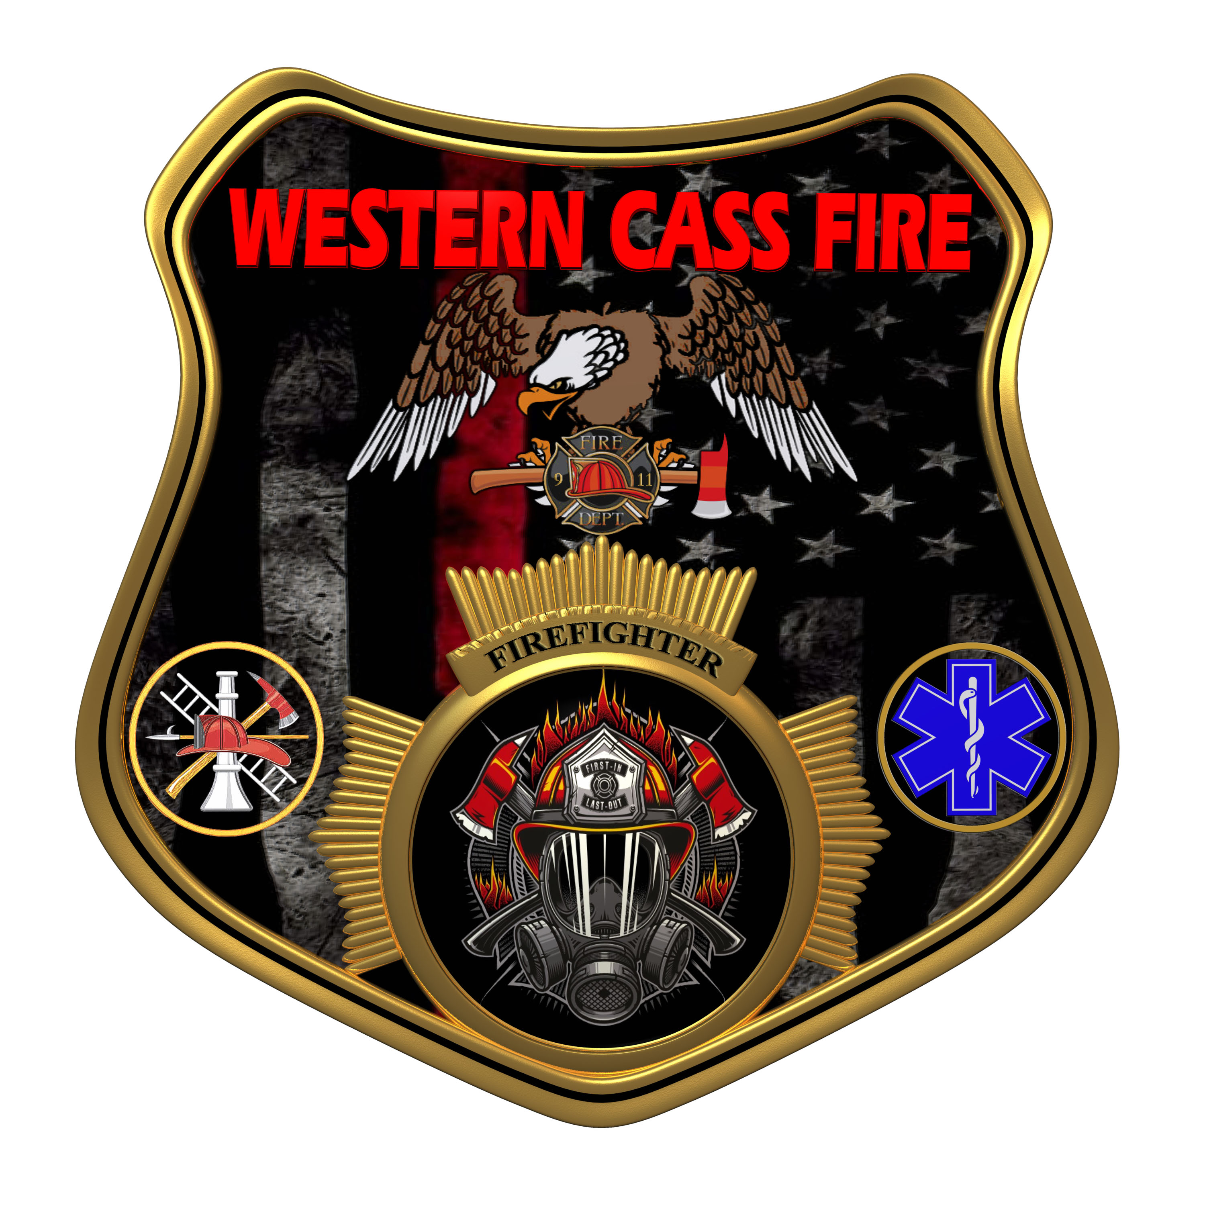 | Minutes  Western Cass Fire Protection District  Tax Levy Hearing  Wednesday, August 24 2023, at 7:30 pm  Fire Headquarters  5 S. Rogers Road, Cleveland, MO 64734  In Person Only  Discussion Protocols and Organization Rules for Meetings:  Questions from the public must be in writing with the following information: Name, Phone #, Physical Address, Email Address.  Board Members will be limited to 3 minutes for discussion of agenda items, twice per item, and discussion of items will last no more than 10 minutes per item.
- Call to Order by the Secretary 7:04 P.M.
- Pledge of Allegiance
3) Roll Call (Quorum)
a) President Sue Hosterman (2019-2025) Present
b) Vice Chair John Webb (2022- 2027) Present
c) Director Tom Reintjes (2023- 2029) Present
d) Director Theresa Hawkins (2020-2025) Present
e) Director Mike Bigg (2021-2027) Present
4) Tax Levy
a) Vice Chair Webb made a motion to adopt the tax levy at .03431 for the general fund, .0404 for the dispatch, total.3835, and new construction at $3850, and I passed.
President and Chair Sue Hosterman - Aye
Vice Chair John Webb - Aye
Director Tom Reintjes - Aye
Director Theresa Hawkins - Aye
Director Mike Bigg - Aye
b) President Hosterman made a motion to adjourn the Tax Levy hearing, and it passed.
President and Chair Sue Hosterman - Aye
Vice Chair John Webb - Aye
Director Tom Reintjes - Aye
Director Theresa Hawkins - Aye
Director Mike Bigg - Aye

5) Adjourn 7:48 P.M.

