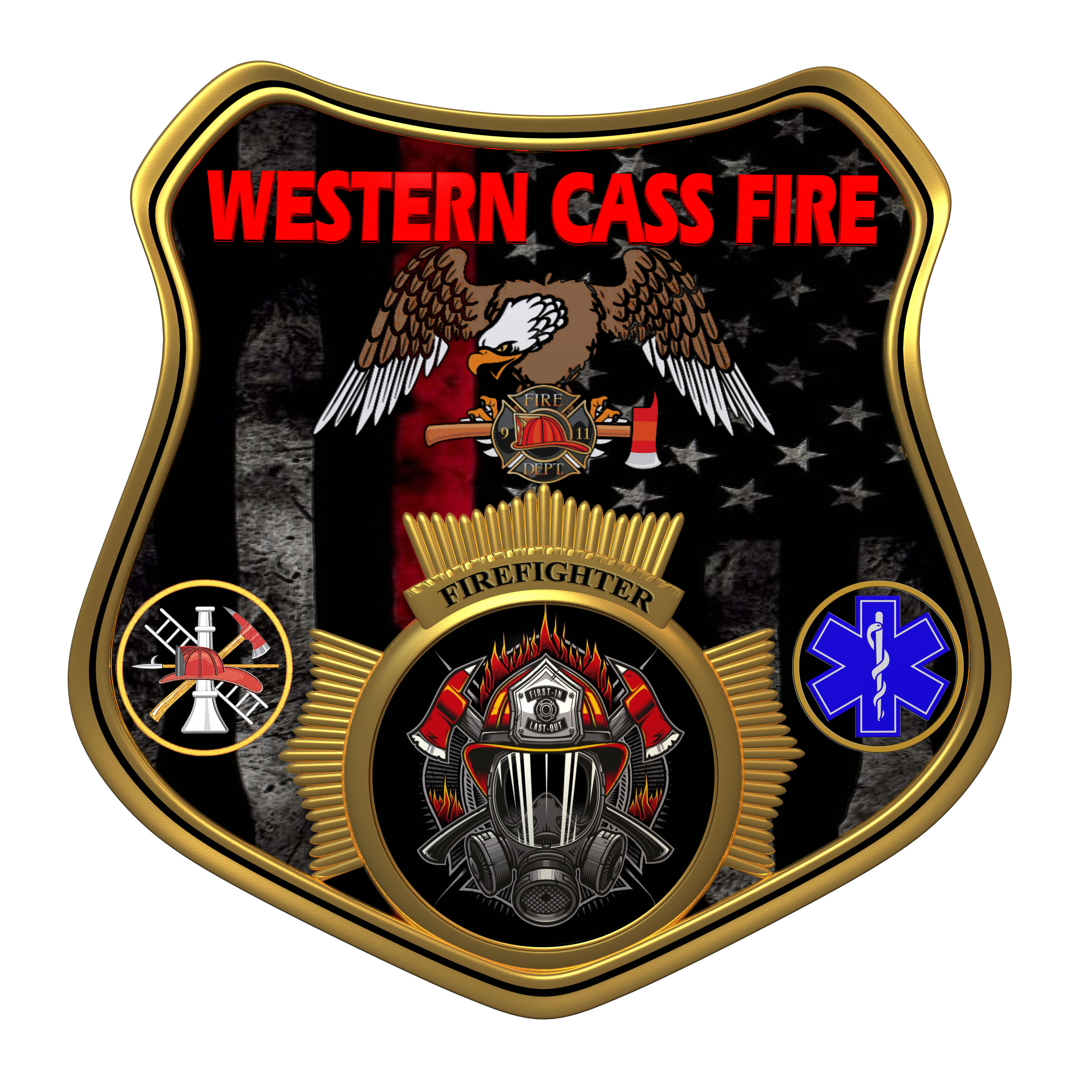 | Minutes  Western Cass Fire Protection District  Regular Session Meeting Outgoing  Tuesday, April 18, 2023, at 7:00 pm  Fire Headquarters  5 S. Rogers Road, Cleveland, MO 64734  In Person Only  Discussion Protocols and Organization Rules for Meetings:  Questions from the public must be in writing with the following information: Name, Phone #, Physical Address, Email Address.  Board Members will be limited to 3 minutes for discussion of agenda items, twice per item, and discussion of items will last no more than 10 minutes per item.
- Call to Order by the Secretary 7:00 P.M.
- Pledge of Allegiance
- Roll Call (Quorum)
a) President and Chair John Webb (2022- 2027) Present
b) Vice Chair Marty Hardman (2022- 2023) Present
c) Director Sue Hosterman (2019-2025) Present
d) Director Kerri VanMeveren (2020-2026) Present
e) Director Darvin Schildknecht (2021-2027) Present
- Agendas
President Webb made a motion to adopt the Tuesday, April 18, 2023 Tentative Agenda Outgoing Board with a treasurer report added to the agenda before the approval of the minutes, and it passed.
President and Chair John Webb - Aye
Vice Chair Marty Hardman - Aye
Director Sue Hosterman - Aye
Director Kerri VanMeveren - Aye
Director Darvin Schildknecht - Aye
5) Approve Minutes
a) President Webb made a motion to approve the February 15, 2023 Regular Session Minutes as provided by the secretary, with a correction on the vote on item B to be changed from nay to abstain, and it passed.
President and Chair John Webb - Aye
Vice Chair Marty Hardman - Aye
Director Sue Hosterman - Aye
Director Kerri VanMeveren - Nay
Director Darvin Schildknecht - Nay
b) President Webb made a motion to approve the February 28, 2023 Litigation Subcommittee Closed Session Minutes as submitted by the secretary, and it passed.
President and Chair John Webb - Aye
Vice Chair Marty Hardman - Aye
Director Sue Hosterman - Aye
Director Kerri VanMeveren - Abstain
Director Darvin Schildknecht - Abstain
c) President Webb made a motion to approve the March 15, 2023 Regular Session Minutes as presented by the secretary, and it passed by consent agenda with no dissention.
d) President Webb made a motion to add the March 30, 2023 Minutes to the agenda and it passed.
President and Chair John Webb - Aye
Vice Chair Marty Hardman - Aye
Director Sue Hosterman - Aye
Director Kerri VanMeveren - Nay
Director Darvin Schildknecht - Aye
e) President Webb made a motion to approve the March 30, 2023 minutes as presented by the secretary, and it was not passed.
President and Chair John Webb - Aye
Vice Chair Marty Hardman - Abstain
Director Sue Hosterman - Abstain
Director Kerri VanMeveren - Nay
Director Darvin Schildknecht - Nay
f) Committee Appointment to Approve This Meeting's Minutes
1) President Webb appointed the committee to approve the April 18, 2023 consisting of John Webb, Sue Hosterman, and Darvin Schildknecht.
2) Director VanMeveren called for a vote on the appointed committee and the vote was not passed.
President and Chair John Webb - Aye
Vice Chair Marty Hardman - Abstain
Director Sue Hosterman - Aye
Director Kerri VanMeveren - Nay
Director Darvin Schildknecht - Nay
6) Special Orders of the Day
1) Declaration of Election Results
2) Tom Reintjes has been elected to the board of the Western Cass County Fire Protection District for a six year term.
7) Departing Remarks
8) Personal Appearances/Public Comment
10) Adjourn Sin Die 7:29 P.M.

