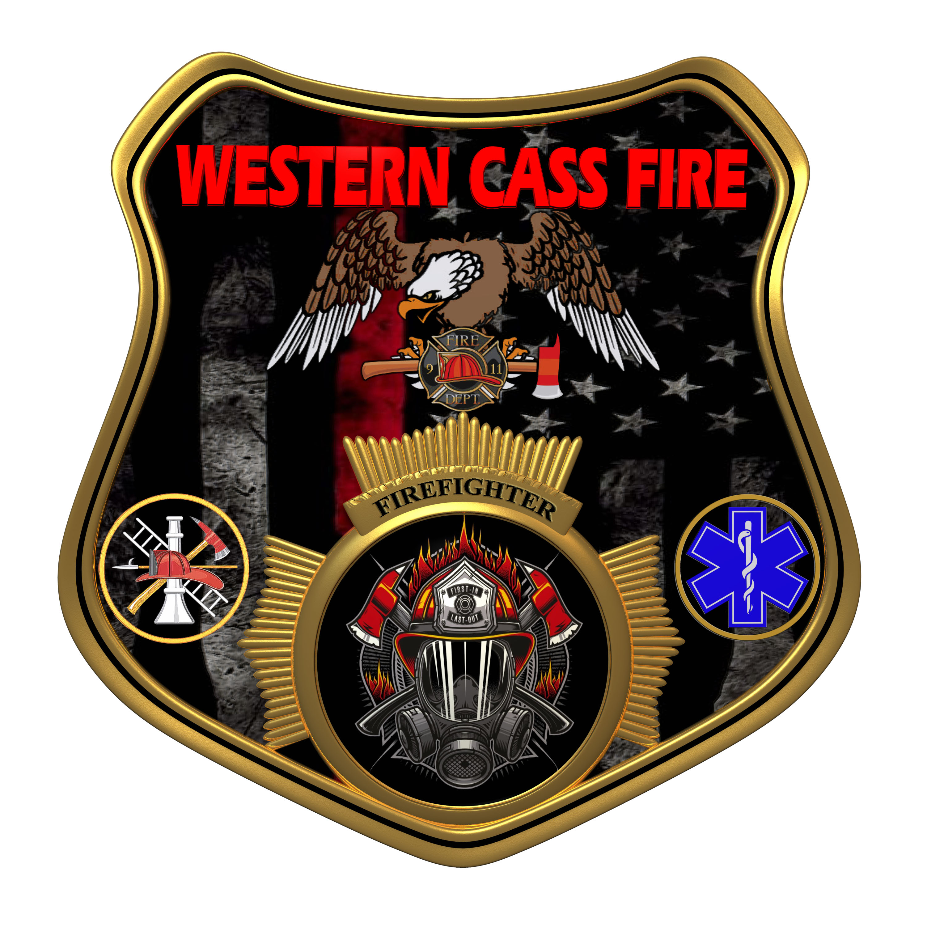 | Tentative Agenda  Western Cass Fire Protection District  Special Session Meeting  Wednesday, March 06, 2024, at 7:00 pm  Fire Headquarters  5 S. Rogers Road, Cleveland, MO 64734  Discussion Protocols and Organization Rules for Meetings:  Questions from the public must be in writing with the following information: Name, Phone #, Physical Address, Email Address.
- Call to Order by the Secretary
- Pledge of Allegiance
3) Roll Call (Quorum)
a) President Sue Hosterman (2019-2025)
b) Vice Chair John Webb (2022- 2027)
c) Director Tom Reintjes (2023- 2029)
d) Director Theresa Hawkins (2020-2025)
e) Director / Treasurer Mike Bigg (2021-2027)
4) Approve the March 06, 2024 Special Session Meeting Tentative Agenda and Additions
5) Public Comments
6) Treasurer Report
7) New Business
a) Open House
b) Chief Credit Limit
8) Unfinished Business
9) Closed Session: Personnel
Personnel matters are confidential until such time as they may be made public by the Board of Directors, and the nondisclosure of such records outweighs the public interest in disclosure of the records as according to RSMo 610.021(3)(13).

10) Adjourn

