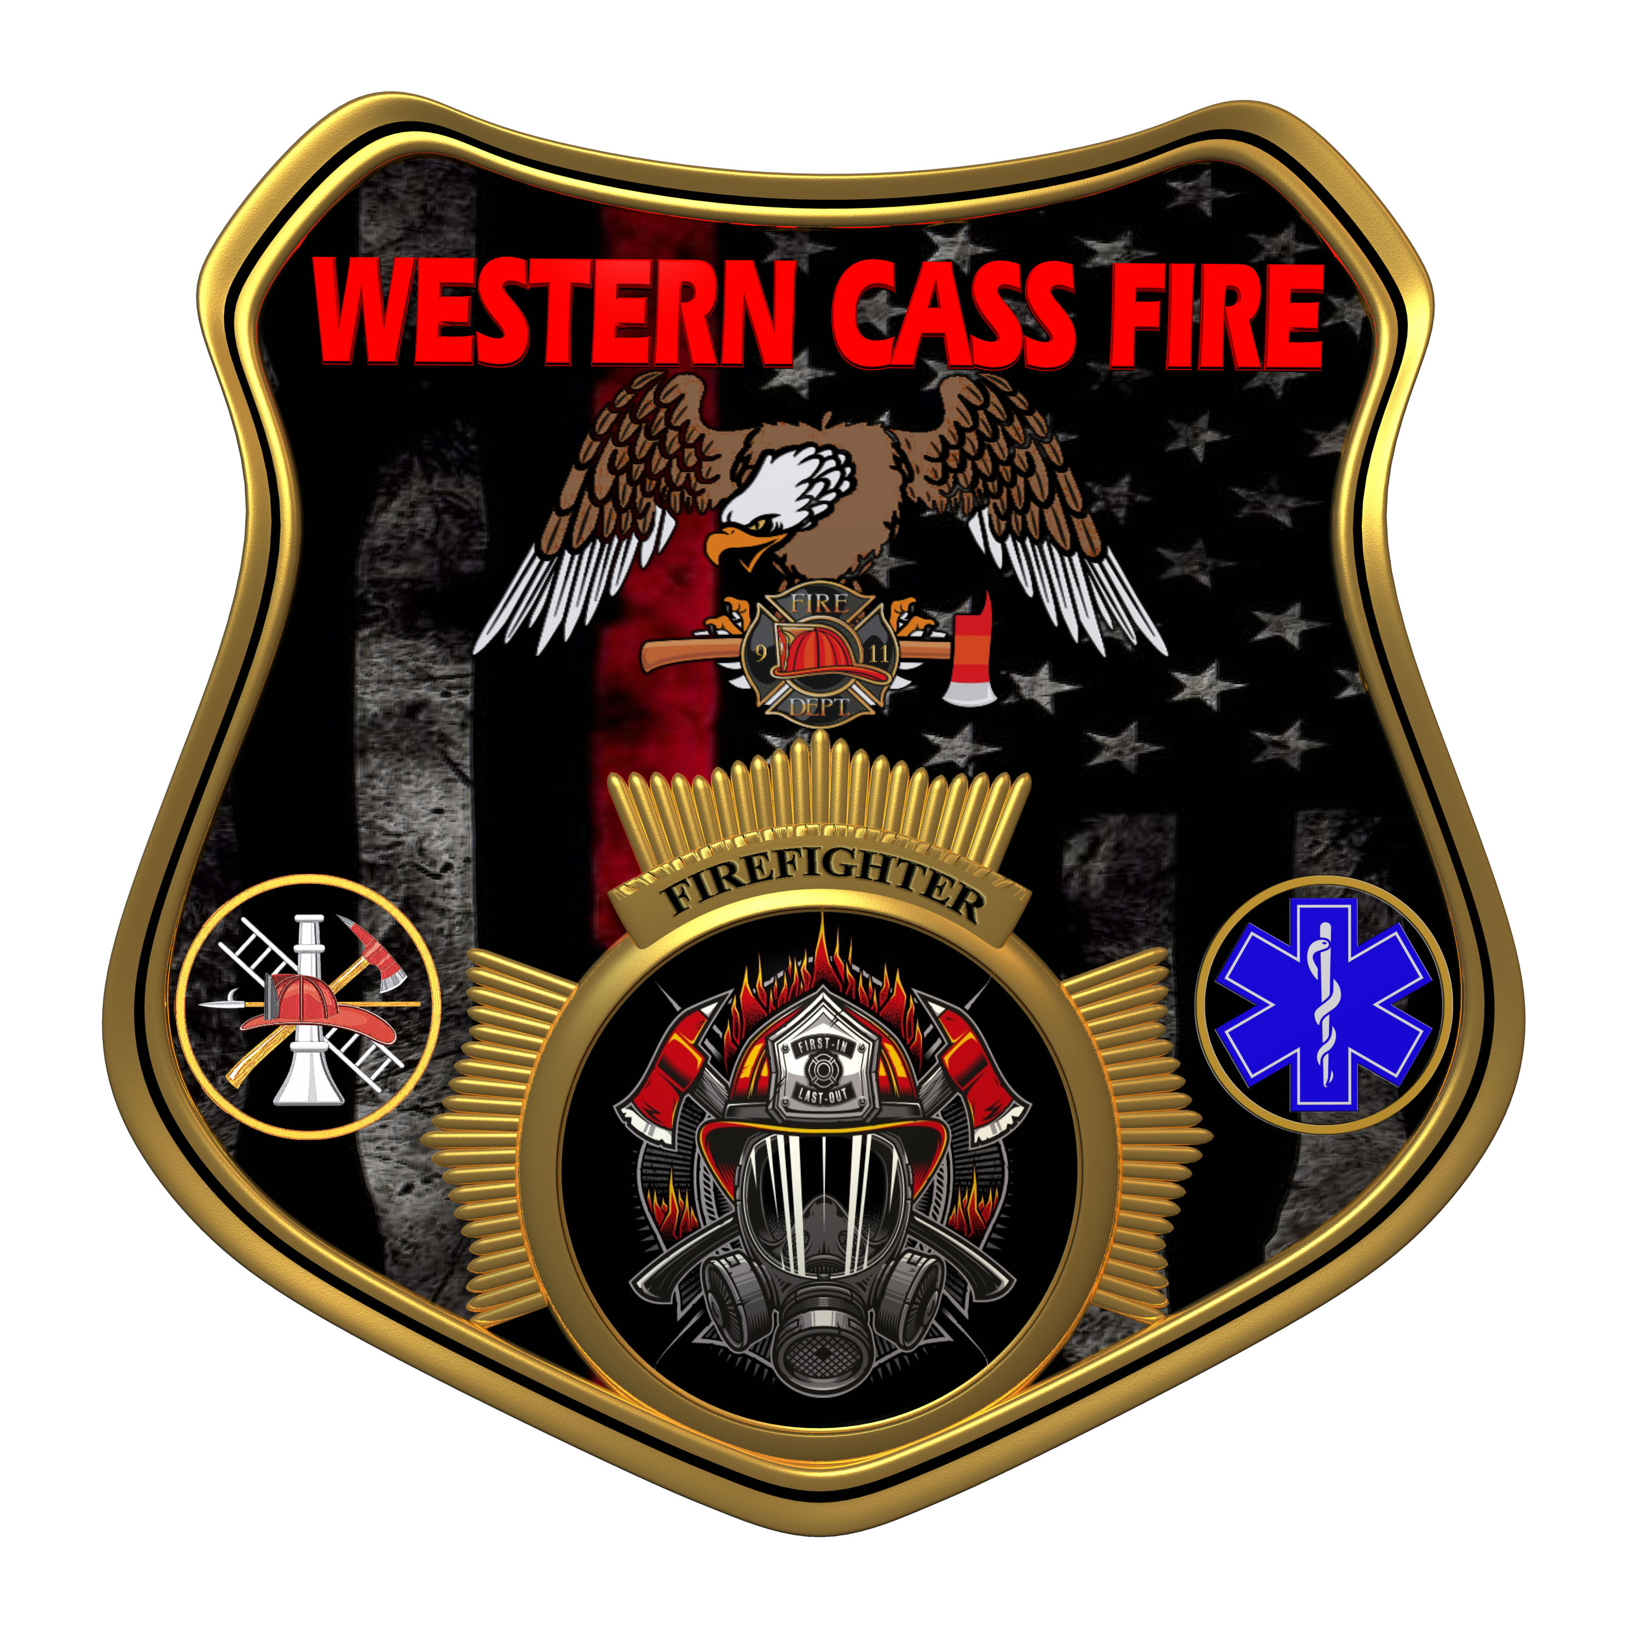 | Tentative Agenda  Western Cass Fire Protection District  Regular Session Meeting Incoming  Tuesday, April 18, 2023, at 7:00 pm  Fire Headquarters  5 S. Rogers Road, Cleveland, MO 64734  In Person Only  Discussion Protocols and Organization Rules for Meetings:  Questions from the public must be in writing with the following information: Name, Phone #, Physical Address, Email Address.  Board Members will be limited to 3 minutes for discussion of agenda items, twice per item, and discussion of items will last no more than 10 minutes per item.
- Call to Order by the Secretary
- Roll Call (Quorum)
a) Director John Webb (2022- 2027)
b) Director Tom Reintjes (2023- 2029)
c) Director Sue Hosterman (2019-2025)
d) Director Kerri VanMeveren (2020-2026)
e) Director Darvin Schildknecht (2021-2027)
3) Votes and Oaths/Affirmations of 2023-2024 Officers
a) Choice of Board Chair and District President
b) Choice of Vice Board Chair and District Vice President
c) Choice of Secretary
d) Appointment of Custodian
e) Election of Treasurer
f) Appointment of Budget officer
4) New Business
a) Depository and Withdrawal Authorizations
b) Reform Litigation Committee
5) Unfinished Business
a) Apparatus Mapping System Demonstration
6) Closed Session - Personnel
Personnel matters are confidential until such time as they may be made public by the Board of Directors, and the nondisclosure of such records outweighs the public interest in disclosure of the records as according to RSMo 610.021(3)(13).
7) Adjourn

