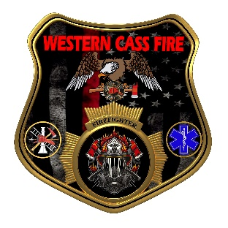 | Tentative Agenda  Western Cass Fire Protection District  Regular Session  Wednesday, November 16, 2022, at 7:00 pm  Fire Headquarters  5 S. Rogers Rd., Cleveland, MO 64734  https://tinyurl.com/5e34569x  Discussion Protocols and Organization Rules for Meetings:  Questions from the public must be in writing with the following information: Name, Phone #, Physical Address, Email Address.  Board Members will be limited to 3 minutes for discussion of agenda items, twice per item, and discussion of items will last no more than 10 minutes per item.
- Call to Order by the Secretary
- Pledge of Allegiance
- Roll Call (Quorum)
a) President and Chair John Webb (2022- 2027)
b) Vice Chair Marty Hardman (2022- 2023)
c) Director Sue Hosterman (2019-2025)
d) Director Kerri VanMeveren (2020-2026)
e) Director Darvin Schildknecht (2021-2027)
- Adopt and Approve Wednesday, November 16, 2022 Tentative Agenda
- Personal Appearances / Public Comments
- Approve Minutes
a) Approve the Special Session minutes of October 03, 2022
b) Approve the Regular Session minutes of October 19, 2022
- Reports
a) Directors Submit Written Reports
b) Treasurer Report Written Report
C) Chief Report Written Report
8) Unfinished Business
a) Station 2 Bay Lights
b) Dr Cusser Contract
c) Insurance Rider
9) New Business
a) Auditor Payment
b) Chief Reimbursement Gasoline
c) Sheriff 22 Addendum
d) Elections
10) Adjourn

