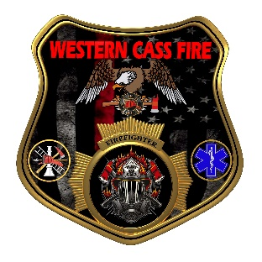 | Tentative Agenda  Western Cass Fire Protection District  Regular Session Meeting  Wednesday, September 20, 2023, at 7:00 pm  Fire Headquarters  5 S. Rogers Road, Cleveland, MO 64734  In Person Only  Discussion Protocols and Organization Rules for Meetings:  Questions from the public must be in writing with the following information: Name, Phone #, Physical Address, Email Address.  Board Members will be limited to 3 minutes for discussion of agenda items, twice per item, and discussion of items will last no more than 10 minutes per item.
- Call to Order by the President
- Pledge of Allegiance
3) Roll Call (Quorum)
a) President Sue Hosterman (2019-2025)
b) Vice Chair John Webb (2022- 2027)
c) Director Tom Reintjes (2023- 2029)
d) Director Theresa Hawkins (2020-2025)
e) Director Mike Bigg (2021-2027)
4) Approve the August 24,2023 open and closed session minutes
5) Director reports (Written Form - Concerning Activities on Behalf of the District Only)
Treasurer’s report
Chief’s report
6) Old business
Banking ABCD
IT update
Magic Jack
Sunshine request
Levy
7) New business
Leaking roof station 2
Treasure and duties
Inventory

8) Closed session Legal and Personnel
Personnel matters are confidential until such time as they may be made public by the Board of Directors, and the nondisclosure of such records outweighs the public interest in disclosure of the records as according to RSMo 610.021(1)(3).

Adjourn
Return to open session
Next scheduled meeting is October 18, 2023

